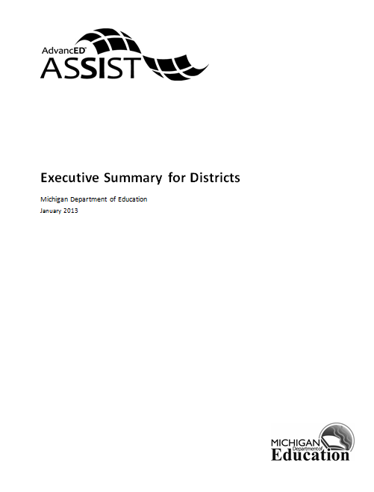

Executive Summary for Districts
The Executive Summary (ES) provides the school an opportunity to describe in narrative form its vision as well as strengths and challenges within the context of continuous improvement. Use the links below to navigate the Executive Summary and respond to the various questions. The responses should be brief, descriptive, and appropriate for the specific section. It is recommended that the responses are written offline and then transferred into the sections below.

Description of the School System
Describe the school system's size, community/communities, location, and changes it has experienced in the last three years. Include demographic information about the students, staff, and community at large. What unique features and challenges are associated with the community/communities the school system serves?

System’s Purpose
Provide the school system's purpose statement and ancillary content such as mission, vision, values, and/or beliefs. Describe how the school system embodies its purpose through its program offerings and expectations for students.

Notable Achievements and Areas of Improvement
Describe the school system's notable achievements and areas of improvement in the last three years. Additionally, describe areas for improvement that the school system is striving to achieve in the next three years.

Additional Information
Provide any additional information you would like to share with the public and community that were not prompted in the previous sections.

